**C:\Users\decaminada\AppData\Local\Microsoft\Windows\Temporary Internet Files\Content.IE5\OPOX2VBP\MC900325652[1].wmf**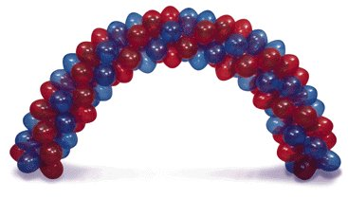

**Notes:**

**Bus will be on the sidewalk between 3200-2200 hallways**

**Rowdy Raiders will be in bus.**

**Student Council members will be placed throughout the route informing students and staff of what to do.**

**All students not in an organization will be in the gym.**

**Students will make their way to the gym after they are filmed and out of the camera view.**

**END: Students in GYM**

**Upstairs Main Hallway**

**START: Kersey**

**5000 Hallway** **Elevator & Counselors**

**4000**

**Stairwell**

**Main Doors**

**Main Hallway**

**Main Hallway**

**2200 Hallway**

**3200 Hallway**